Pol. 1 1.00 ks

1
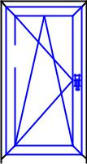

1250 1280

30

680

---------------------------------------------------------------------------

Pol. 2 1.00 ks

1
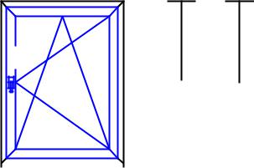

1250 1280

30

940

---------------------------------------------------------------------------

Pol. 3 | 1.00 ks
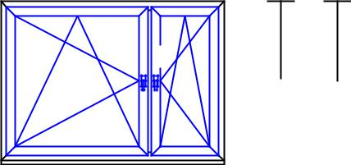

1 | 2
 | 1250 1280
 | 30
1165 | 585
1750

---------------------------------------------------------------------------

Pol. 4 | 1.00 ks

1 | 2
 | 1250 1280
 | 30
1165 | 585
1750

---------------------------------------------------------------------------

Pol. 5 1.00 ks

1
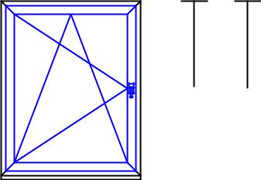

1460 1490

30

1160

---------------------------------------------------------------------------

Pol. 6 | 1.00 ks
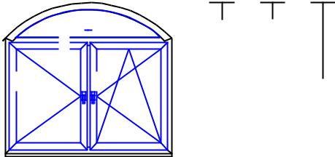

 | 398.4 370
 | 1
2 | 3 | 1600
 | 1171.61200
 | 30 | 30

- 860

1720

- x FIX v rámu
- x Křídlo
---------------------------------------------------------------------------

Pol. 7 1.00 ks

1
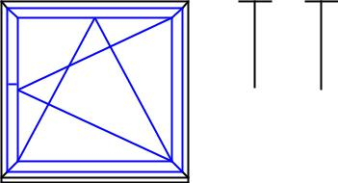

1180 1210

30

1250

---------------------------------------------------------------------------

Pol. 8 1.00 ks

1
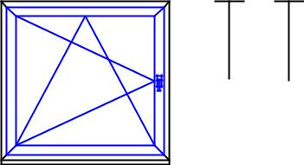

1180 1210

30

1250

