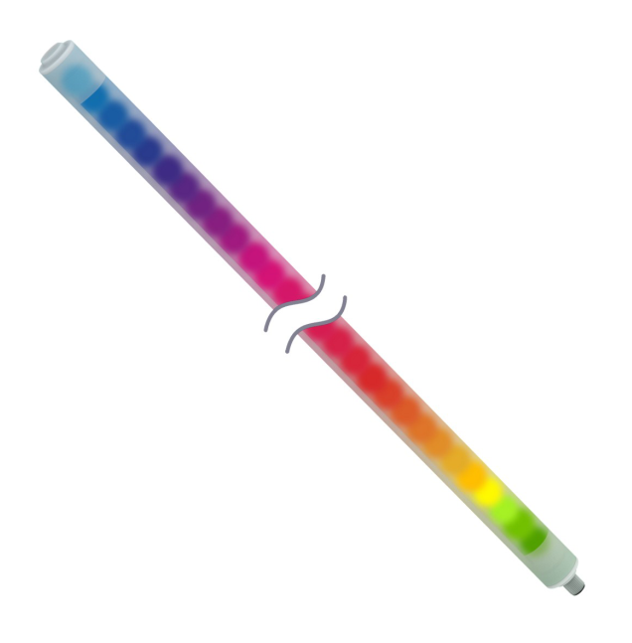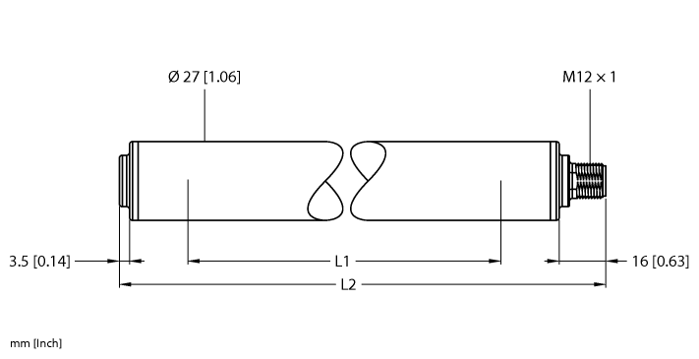

|  |  |
| --- | --- |
| **10203076** | **NEW LED LIGHT, ROUND, WLS27XW990DSQ-804746, EQP** |

