[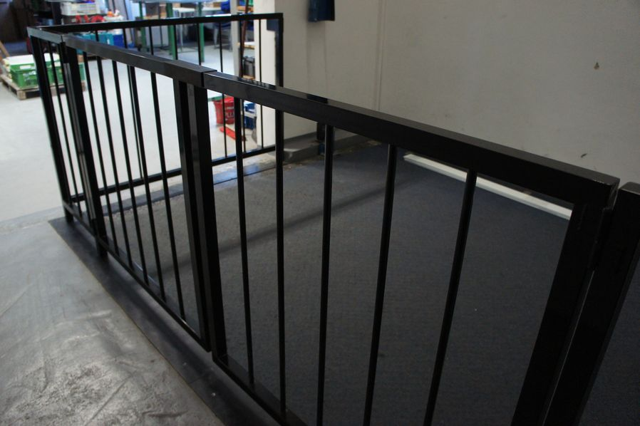](https://www.google.cz/url?sa=i&url=https://www.kovovyroba-crdesign.cz/zamecnicka-vyroba-brno/vyroba-zabradli&psig=AOvVaw1pnLCUFTaL5E20gMH0PHkK&ust=1582887815490000&source=images&cd=vfe&ved=0CAIQjRxqFwoTCIDRiOLK8ecCFQAAAAAdAAAAABAE)