

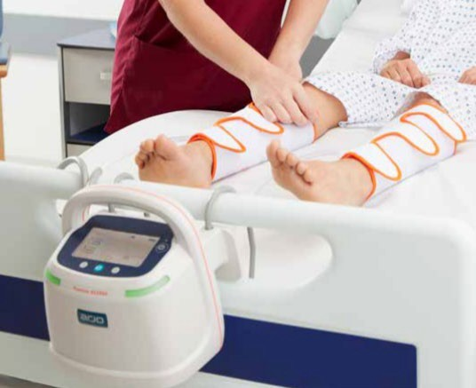

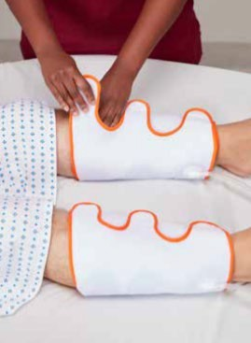

Advanced Medical Solutions, s.r.o. | Vídeňská 101/119 | 619 00 Brno | [www.amsolutions.c](http://www.amsolutions.cz/)

*A*

Advanced Medical Solutions

