[[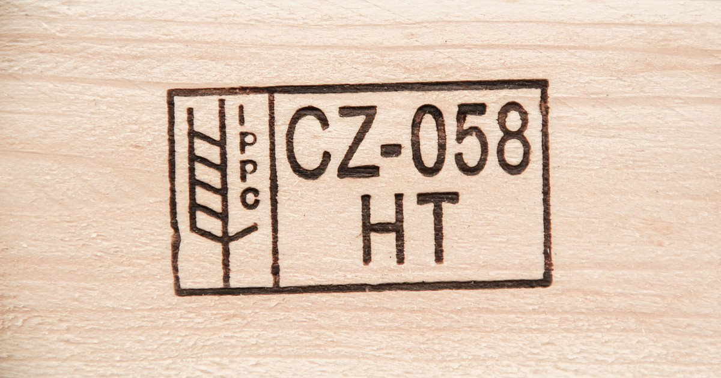](https://www.google.com/url?sa=i&url=https%3A%2F%2Fwww.klaustimber.cz%2Fippc-certifikace&psig=AOvVaw2oTFj_Jw5z5M1svtY0Wq1J&ust=1651068409438000&source=images&cd=vfe&ved=0CAwQjRxqFwoTCLDJtKLzsfcCFQAAAAAdAAAAABAP)1 200 × 630](https://www.google.com/url?sa=i&url=https%3A%2F%2Fwww.klaustimber.cz%2Fippc-certifikace&psig=AOvVaw2oTFj_Jw5z5M1svtY0Wq1J&ust=1651068409438000&source=images&cd=vfe&ved=0CAwQjRxqFwoTCLDJtKLzsfcCFQAAAAAdAAAAABAP)

[[](https://www.klaustimber.cz/ippc-certifikace)](https://www.klaustimber.cz/ippc-certifikace" \o "IPPC certifikace - norma a význam označení | KLAUS Timber a.s." \t "_blank)