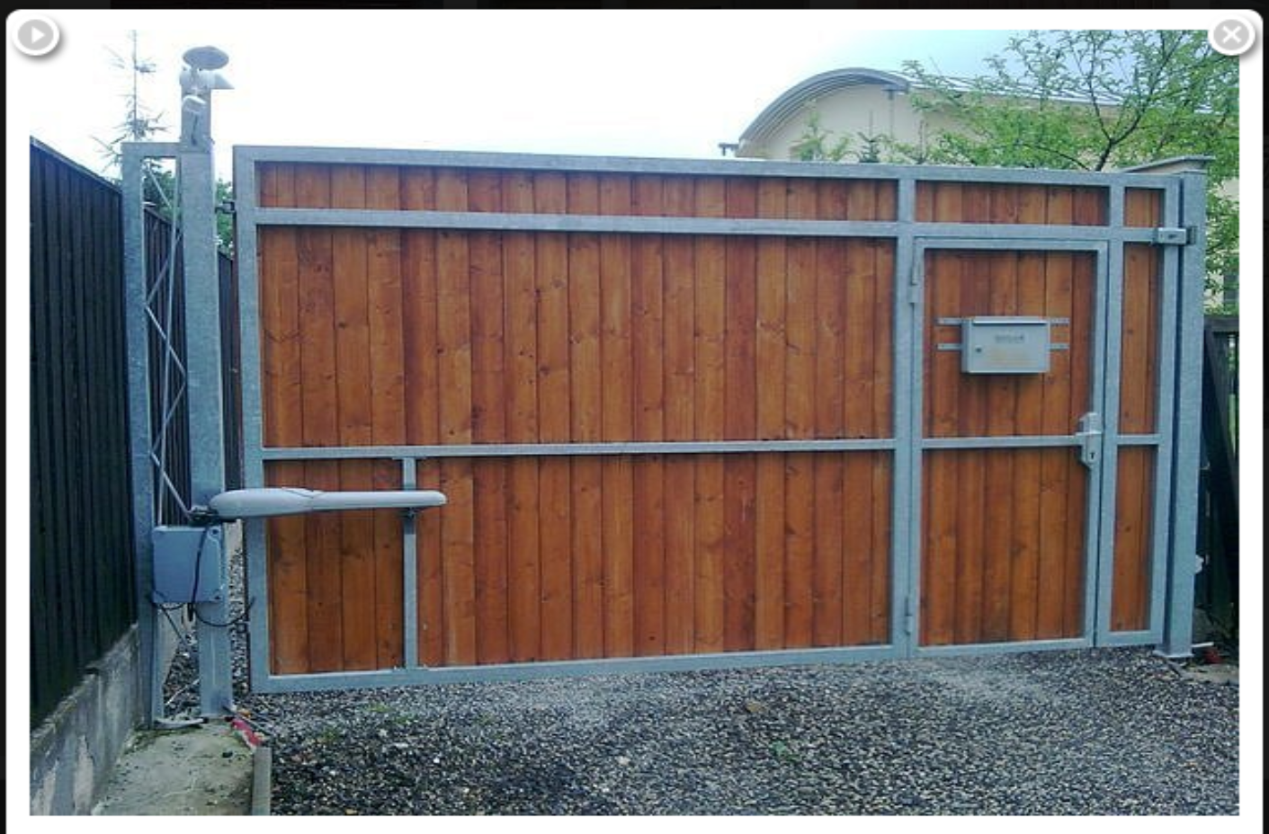

[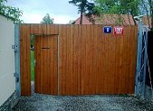](http://www.branyavrata.cz/brany-a-pohony/tc.php?src=1200@1000@images/reference/prod-66-kridlove-brany-14.jpg)