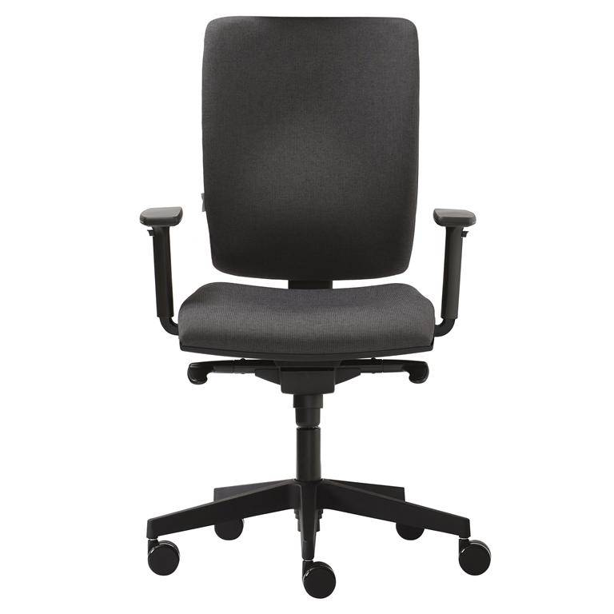 [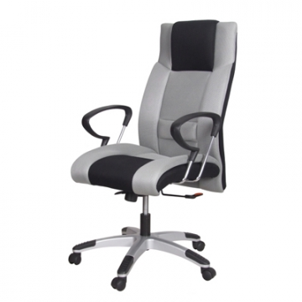](http://www.vybersito.sk/images/zbozi/255/025360-036215.jpg)

[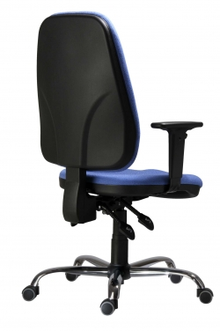](http://www.antares.cz/media/catalog/product/cache/1/image/600x/af097278c5db4767b0fe9bb92fe21690/1/5/1540_asyn_c_br20_1_1.jpg) [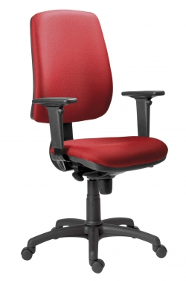](http://www.antares.cz/media/catalog/product/cache/1/image/600x/af097278c5db4767b0fe9bb92fe21690/1/6/1640_syn_athea_br20_1_2.jpg) [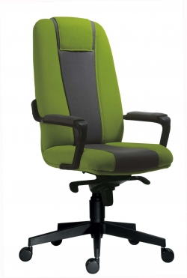](http://www.antares.cz/media/catalog/product/cache/1/image/600x/af097278c5db4767b0fe9bb92fe21690/4/0/4000_03_1_1.jpg)