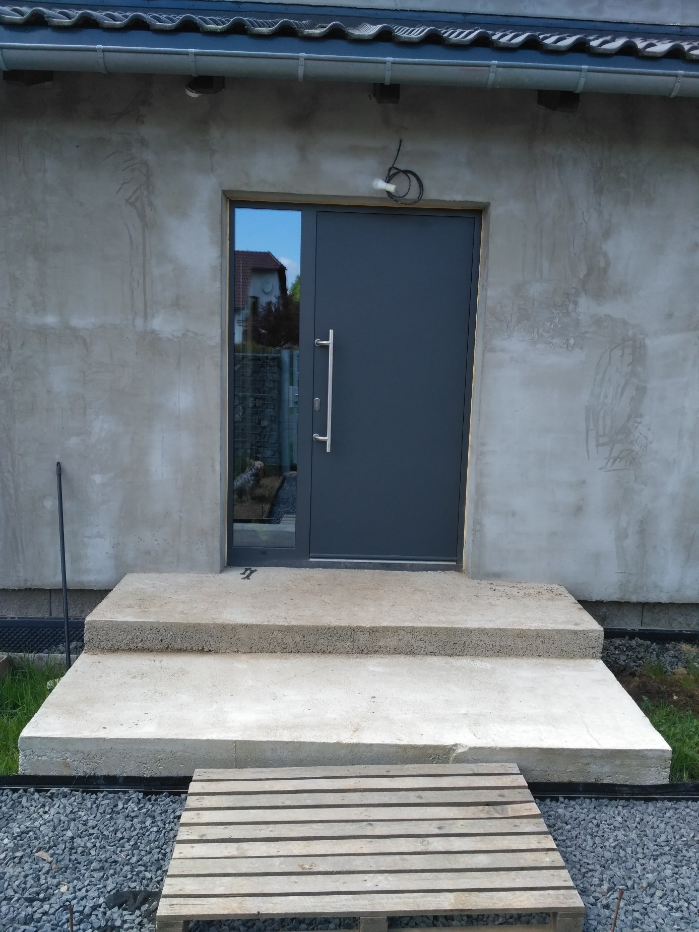
252, 246, 85, 15, 175,

