[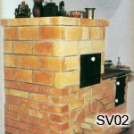](http://www.kachliar.sk/kach/wp-content/uploads/2011/12/024.jpg)