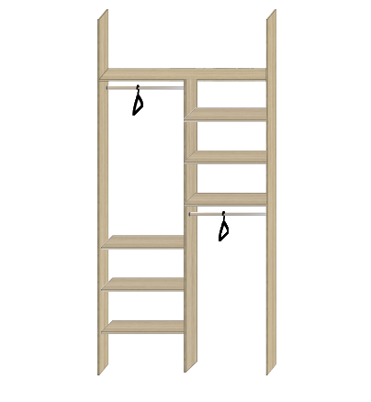

150 cm

263cm

80 cm

stena

priestor

stena

priestor

80 cm

263cm

150 cm

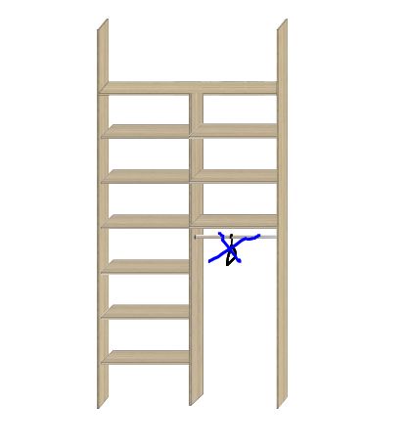

100 cm

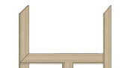

60 cm

80 cm