[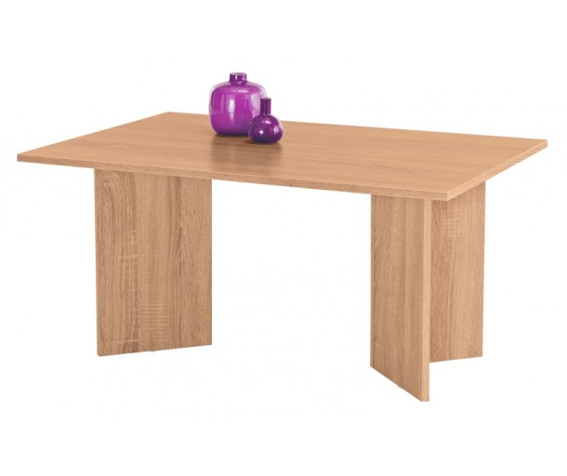](https://www.asko-nabytek.cz/images/asko_nabytek_cz/original/93/4093/4093-konferencni-stolek.jpg)