 Salamander blueEvolution 82MD…….1ks (820 x 1305mm)

 Salamander blueEvolution 82MD…….1ks (820 x 1305mm)

 Salamander blueEvolution 82MD…….1ks (1430 x 1305mm)

Salamander HST…..1ks (3200 x 2255mm)

 Salamander blueEvolution 82MD…….1ks (820 x 1305mm)

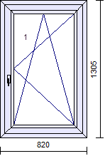 Salamander blueEvolution 82MD…….1ks (820 x 1305mm)

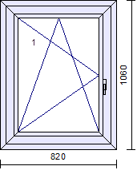

Salamander blueEvolution 82MD…….1ks (820 x 1060mm)

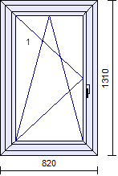 Salamander blueEvolution 82MD…….1ks (820 x 1310mm)

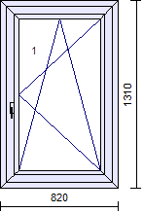 Salamander blueEvolution 82MD…….1ks (820 x 1310mm)