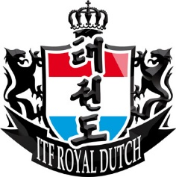
Royal Dutch Open 2015
International Taekwon-Do Championship
Saturday March 14th 2015

Open to all ITF Tae Kwon-Do members of Choi Jung Hwa all over The World
For Colored belts and Black belts

Individual Sparring – Patterns – Special Techniques – Power Breaking

Location
Sportcomplex Koning Willem Alexander
Bennebroekerweg 800
2134 AB Hoofddorp
The Netherlands

Invitation will follow soon
