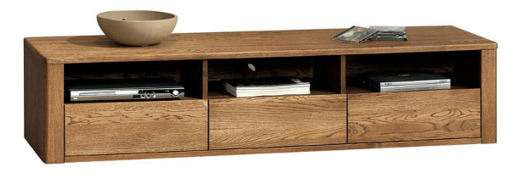

Vyska 60 cm vcetne nozicek
hloubka 42cm
delka 200cm
nozicky- spalicek 10x10x10cm

material- buk, dub
barva orech

