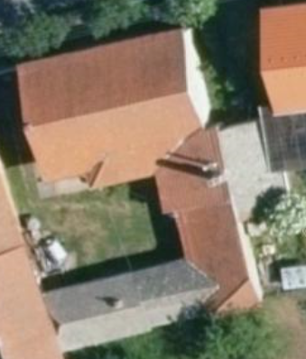

5 m

4 m

5 m

10 m

8 m

7 m

L=13 m