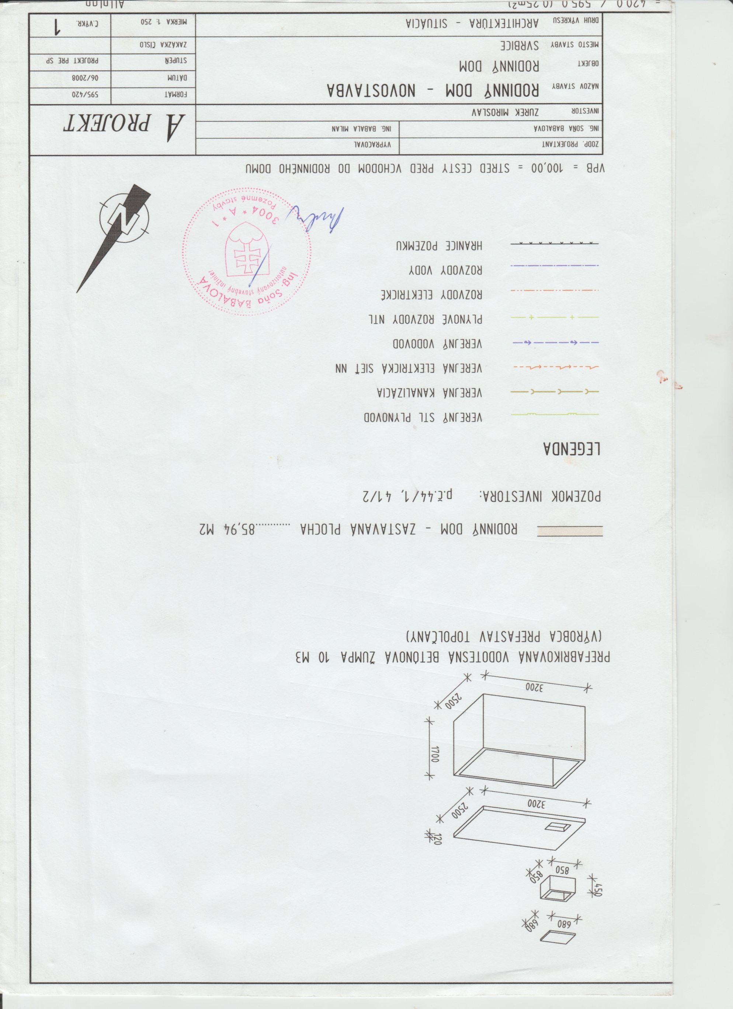,

,0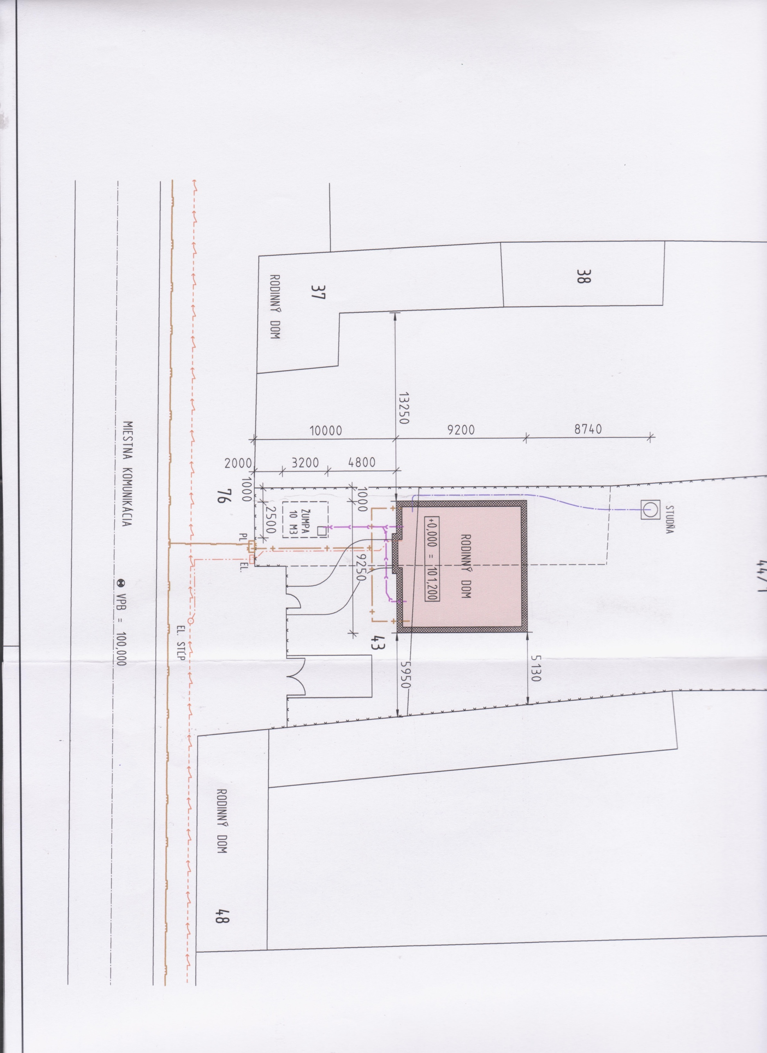11

47/1

1250

40/1

10000

1000

3600

44­­­/1

Dielna